Detailed descriptions of the methods that we’re trying are below
7/4 | 7/11 MVP | 7/18
- Set up GitHub repo  - Try YOLO instead of Google Cloud API  - Try TwelveLabs Video Intelligence API (an alternative to Google’s Video Intelligence API) with Gemini | - Set up method 1 and method 3:  - Method 1: Google Cloud API for Video Intelligence (object tracking) + Gemini (analysis)  - Method 3: Robotics model gemini-robotics-er-1.6-preview  - Try both methods to see if they are of any use | - Make interface on TeamTrack website for the best method

Videos: https://discord.com/channels/851308226120384543/1431355418151620782/1475014156779257917
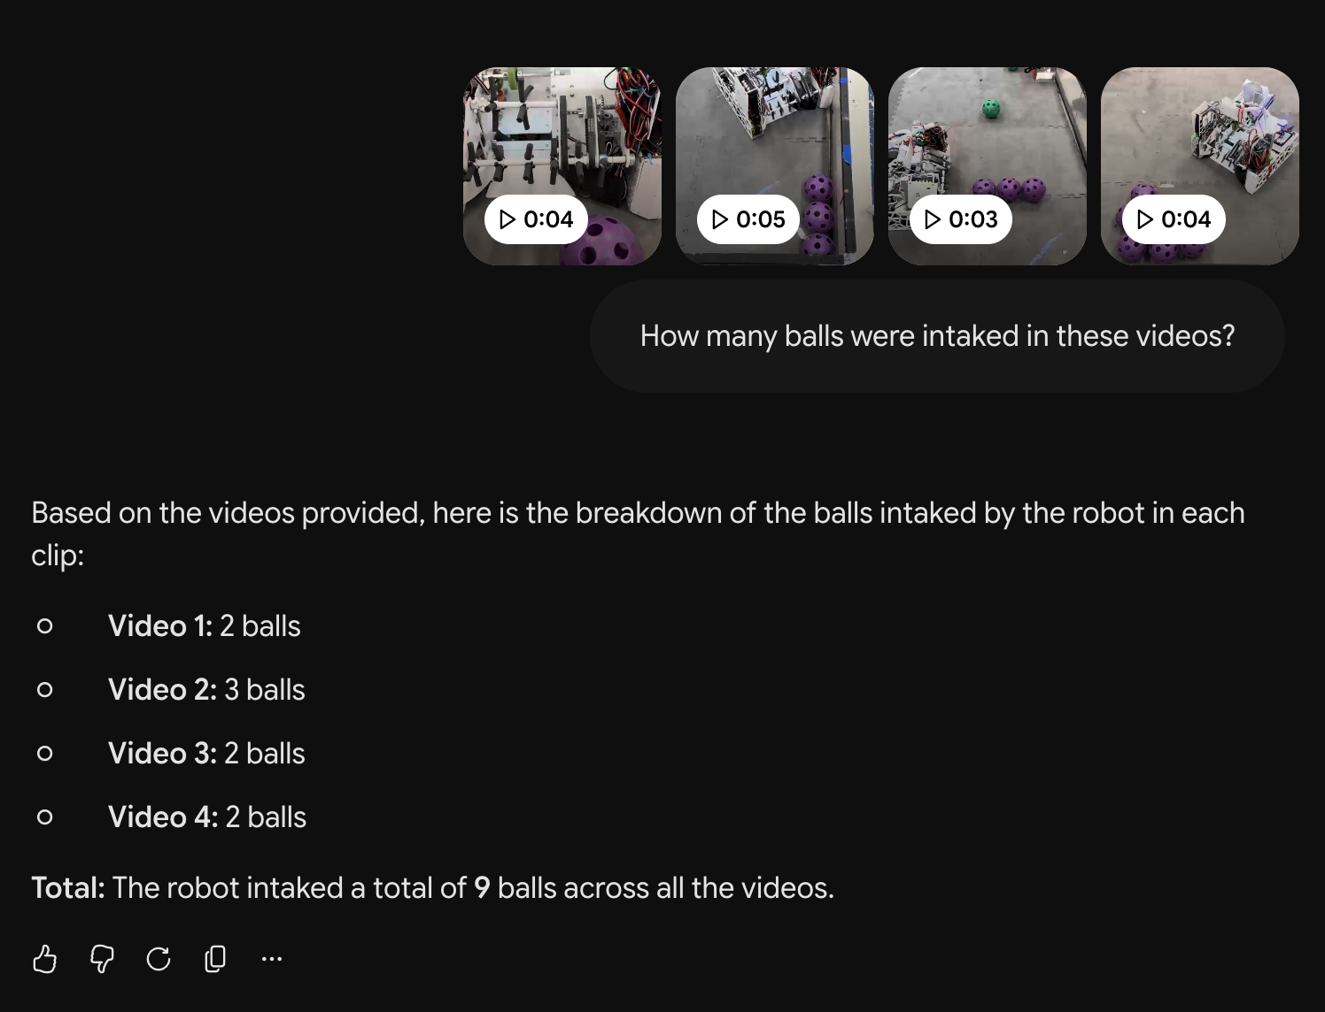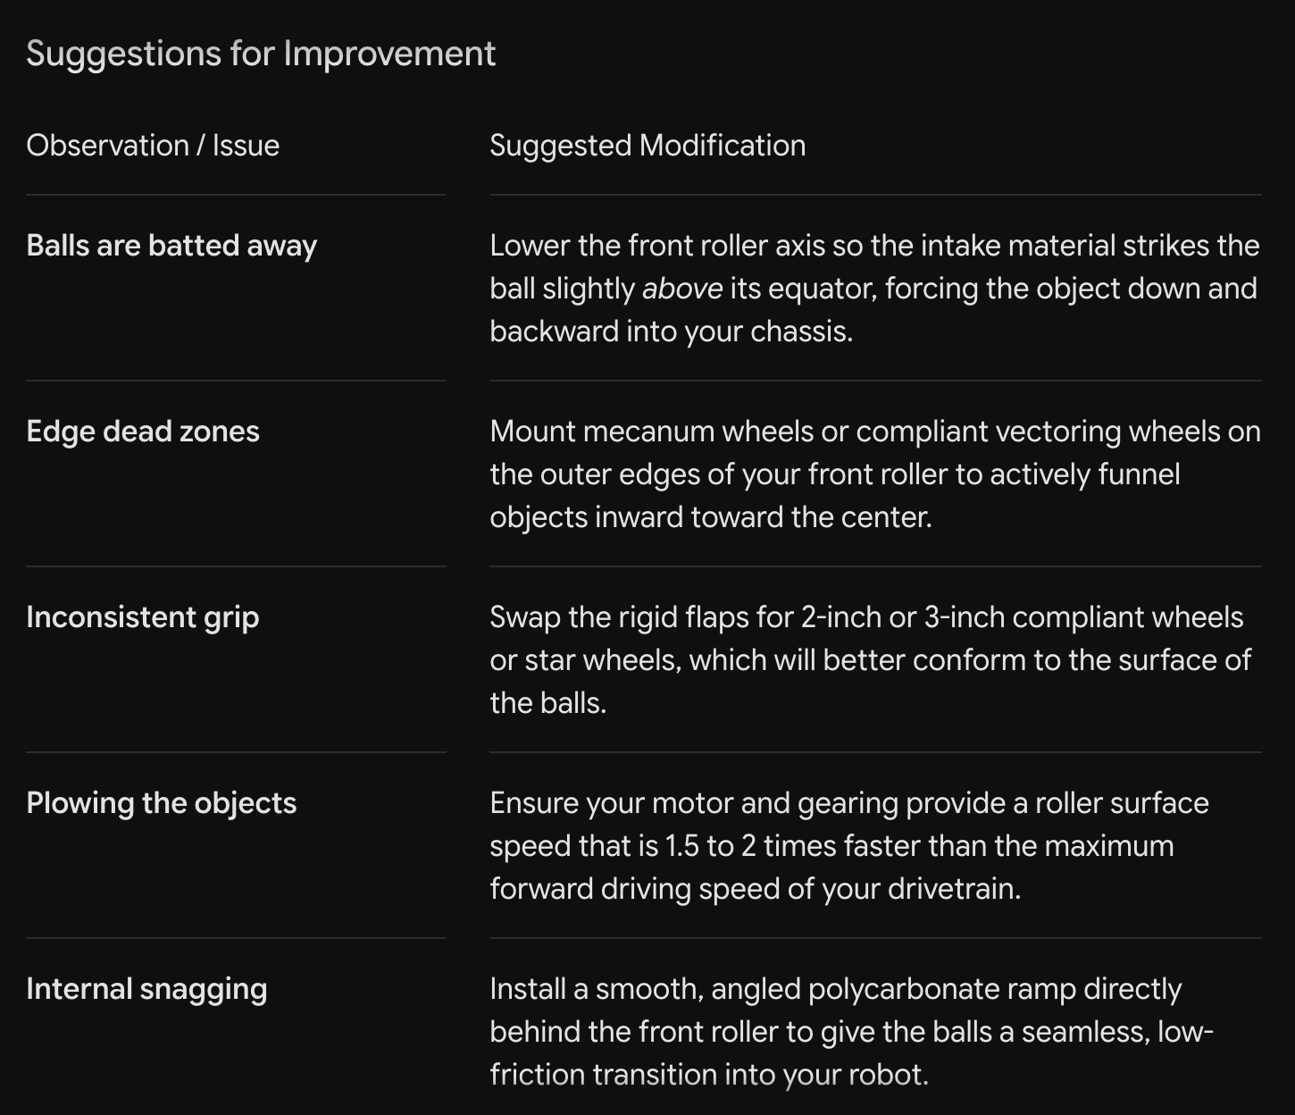
First screenshot: incorrect on Videos 1, 3, and 4
Second screenshot: only 2 and 4 are useful advice
The reason (in theory) that these are so off is because it’s running at 1 FPS. Using the API we can change it to 30 FPS, hopefully it gets better.

Method 1:
Video intelligence / computer-vision APIs (best for measurement and tracking)
If you want structured data — where a mechanism is at each moment, how fast it moves, object tracking — these give you JSON output instead of prose. The leading options are Google Cloud Video Intelligence API, Amazon Rekognition Video, and Azure AI Video Indexer, which do object tracking, label detection, and text/OCR. Twelve Labs is the most video-native API path, with its Marengo and Pegasus foundation models built specifically for video understanding.
A common pattern is combining both — using a Video Intelligence API for object tracking and Gemini for natural-language "what's happening and why" analysis in the same pipeline.

How it works (the flow)
The two tools cover different layers — one measures, one interprets — and you chain them:
- Capture your robot at 30 FPS (phone slow-mo or a decent camera) and save the clip.
- Upload to Google Cloud Storage. The Video Intelligence API reads stored video from a GCS bucket.
- Object-tracking pass. Send the clip to the Video Intelligence API with the OBJECT_TRACKING feature (optionally TEXT_DETECTION, SHOT_CHANGE_DETECTION). It returns JSON with bounding boxes, track IDs, and timestamps for each object across frames. Object tracking returns bounding boxes and track IDs across frames so analytics can count or follow objects through time. This is your quantitative layer — you can derive speeds, trajectories, cycle times, and pinpoint the exact frame where a mechanism jams.
- Pick the key moments from that JSON (e.g., the intake cycle, the shooter release) and extract those frames or short segments.
- Gemini pass. Send the clip (or just the key segments/frames) plus the tracking JSON to Gemini with a prompt. Gemini gives the qualitative layer — reasoning over both the pixels and the numbers you fed it: "the intake loses contact at this angle because…, try…". Feeding it the tracking data means it reasons over concrete measurements, not just what it sees.
- Store both outputs together (a file, or BigQuery if you want to query across sessions). This is exactly the pattern Google documents — the Video Intelligence API for structured detection and Gemini's multimodal capabilities for natural language understanding, combined into a pipeline that detects what's in a video and understands what it means.
Method 2:
Same as method 1 except using TwelveLabs instead of Google’s Video Intelligence API.

Method 3:
Google recently released a robotics-focused model, gemini-robotics-er-1.6-preview, with improved spatial and physical reasoning capabilities. It's aimed more at robot control than at "critique my design," but the physical-reasoning improvements could be interesting for mechanism analysis if you're comfortable in the API.

Pricing:

Method | Item | What it covers | Free tier | Paid rate
1 | Video Intelligence — object tracking | Quantitative tracking (bounding boxes, track IDs, timestamps) | First 1,000 min/month free | $0.15/min stored ($0.17/min streaming); billed per minute, so 30 FPS adds nothing
1 | Gemini — analysis | Natural-language "what / why" | Flash free tier (rate-limited) | ~$0.23/min of 30 FPS video on Gemini 3 Flash ($0.50/1M input tokens); video is 258 tokens/sec at 1 FPS, so frame rate sent to Gemini is the main cost lever
2 | TwelveLabs — indexing (Marengo) | Makes video searchable | Up to 10 hours (600 min) free | $0.042/min (one-time per video)
2 | TwelveLabs — Pegasus Analyze | Video analysis | (within free plan) | $0.021/min input + $0.0075 per 1K output tokens
2 | TwelveLabs — search | Natural-language queries | — | $4 per 1,000 queries
2 | TwelveLabs — infrastructure | Embedding storage / upkeep | — | $0.0015/min per month (cumulative)
2 | Gemini — analysis (if layered on) | Same role as Method 1 | Same as above | Same as Method 1 row
3 | gemini-robotics-er-1.6-preview | Spatial / physical reasoning | Preview | Not on the standard price table; bills per-token — verify in console
Credits | Google Cloud new-account credit | Offsets all Google usage | $300 for new customers | —

Bottom line: with the $300 Google credit and TwelveLabs' free 600 minutes, early testing across all three methods should cost effectively $0, with a realistic ceiling of single-digit to low-tens of dollars per month even if you ramp up.

